Report

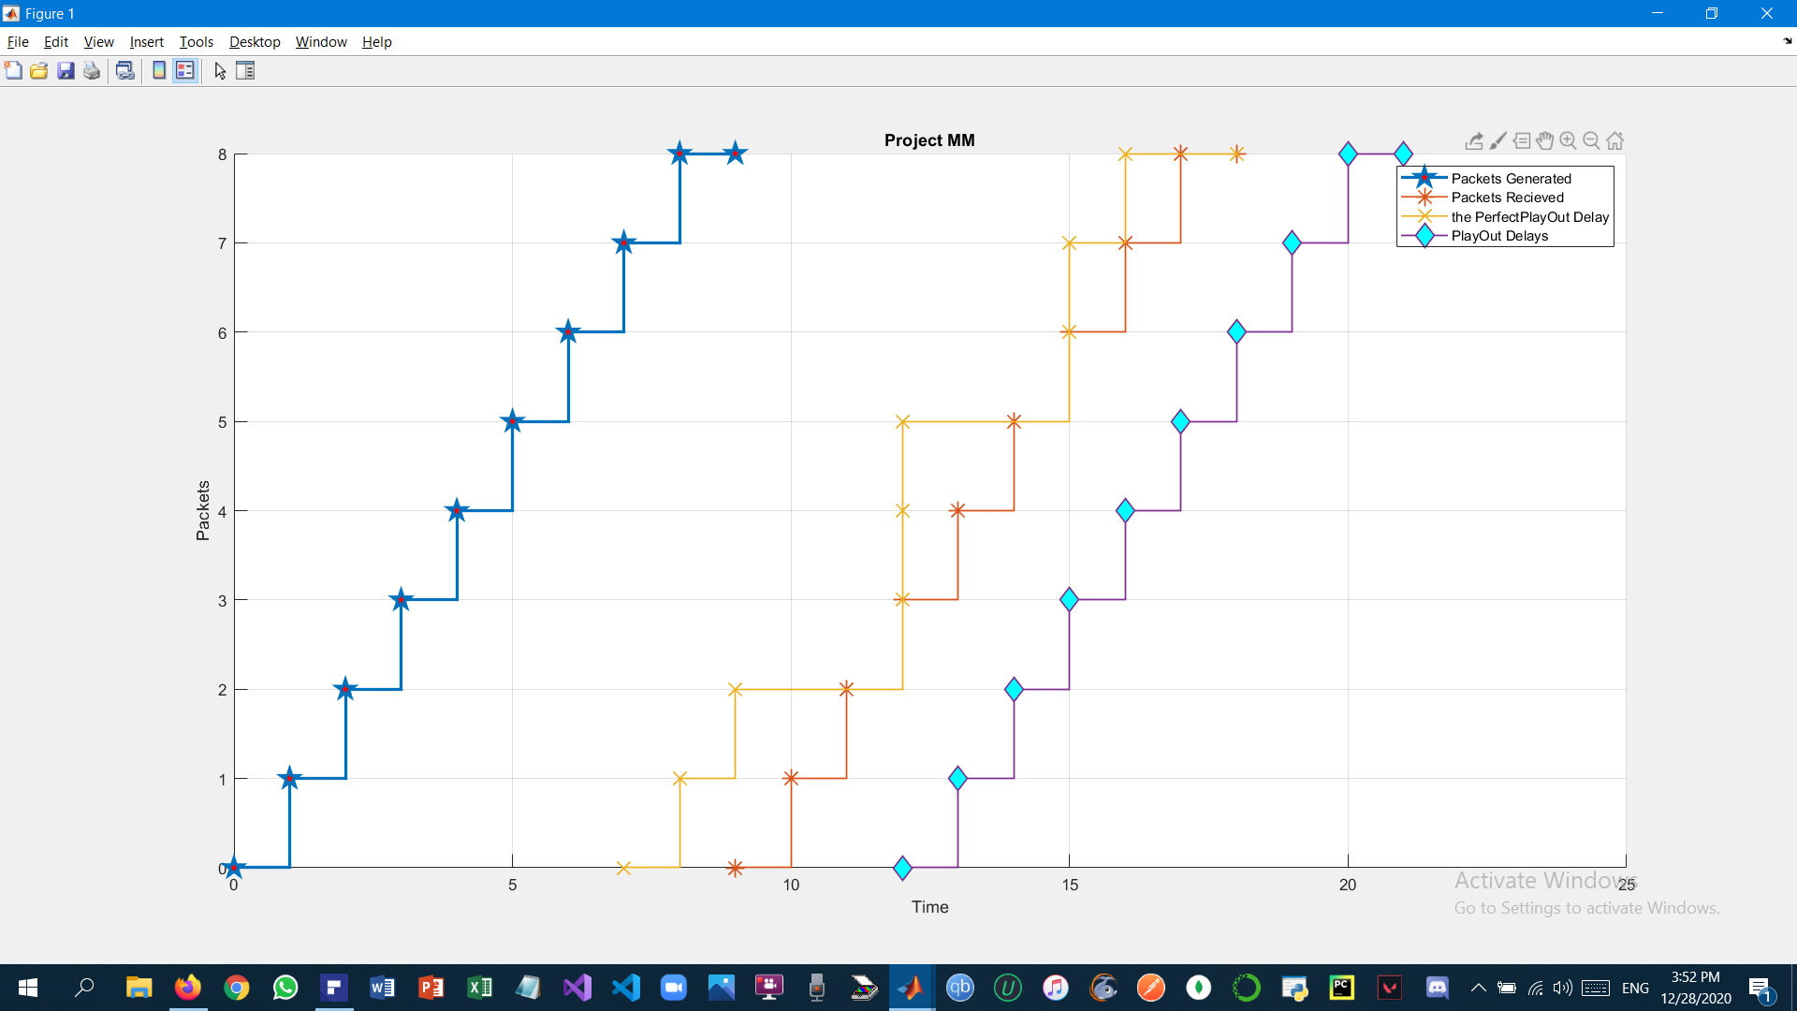

(Ω)There are 4 graphs:

1. Packets generation curve
2. Packets received curve
3. Perfect playout curve
4. Playout curve

(Ω)The inputs:

1. Start time
2. Number of packets
3. Network delays in an array form
4. The desired playout value
5. Buffer size

(Ω)The outputs in the window command:

1. The Estimated Playout Delay which is calculated with µ = 0.1 to tell the beginning of a talk spurt
2. The perfect Playout Delay which is calculated from the network delays and the generation times
3. The buffer array which contains the exact value in the buffer at each second

(Ω)Ex:

1. Start time = 1
2. Number of packets = 8
3. Network delays = [7,7,9,8,7,9,8,8]
4. Playout Value = 5
5. Buffer size = 4
6. Estimated Playout Delay = 4.5224
7. Perfect Playout Delay = 2

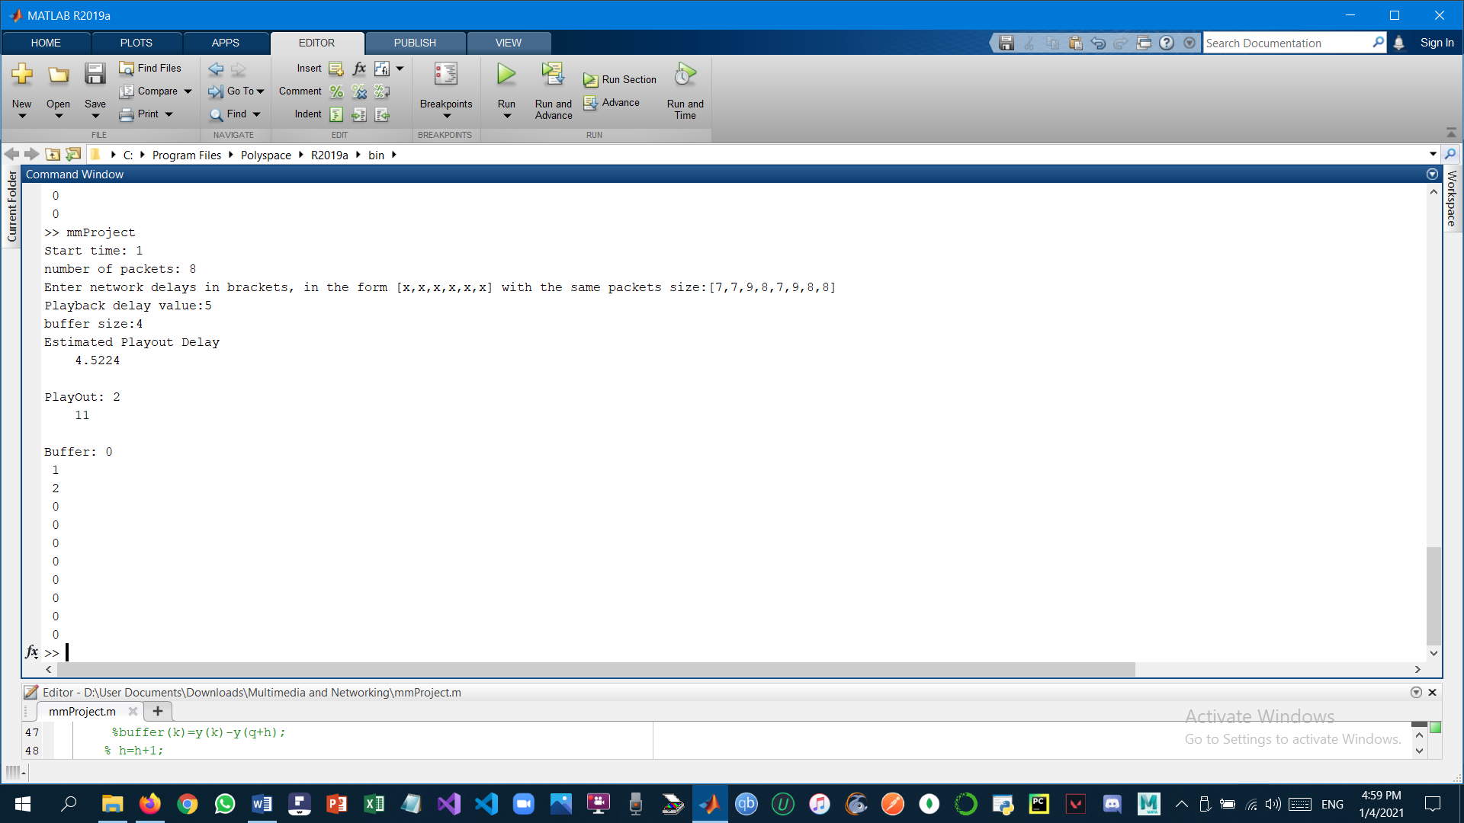

(Ω)Code:

prompt = 'Start time: ';

start_time = input(prompt);

prompt2 = 'number of packets: ';

packets_number = input(prompt2);

prompt4 = 'Enter network delays in brackets, in the form [x,x,x,x,x,x] with the same packets size:';

ND = input(prompt4);

prompt5 = 'Playback delay value:';

PD = input(prompt5);

prompt3 = 'buffer size:';

buffer_size = input(prompt3);

buffer=zeros(packets_number);

ED=0;

ND1=[ND(1)+start_time-1,ND,packets_number+start_time];

x=[start_time-1,start_time:(packets_number+start_time)];

y=[0,1:packets_number,packets_number];

ma=max(ND);mi=min(ND);q=ma-mi;shift=ma-mi+start_time+ND(1)-1;

x2=[start_time-1+shift,start_time+shift:(packets_number+start_time+shift)];

if(PD>=q)

x3=[x2(1)+PD-2,x2(1)+PD-1:packets_number+PD+x2(1)-1];

else

disp("Error in playout will occur as it needs to be more than ")

disp(q)

end

x4=x+ND1;

for i=1:packets_number

ED=(1-0.1)*ED+0.1*ND(i);

end

disp("Estimated Playout Delay")

disp(ED)

fmt3=['PlayOut:' repmat(' %1.0f\n',1,numel(q))];

fprintf(fmt3,q)

figure

hold on

grid on;

stairs(x,y,'LineWidth',2,'Marker','p','MarkerFaceColor','r','MarkerSize',12);

stairs(x2,y,'LineWidth',1,'Marker','*','MarkerFaceColor','c','MarkerSize',12);

stairs(x4,y,'LineWidth',1,'Marker','x','MarkerFaceColor','c','MarkerSize',12);

stairs(x3,y,'LineWidth',1,'Marker','d','MarkerFaceColor','c','MarkerSize',12);

legend("Packets Generated","Packets Recieved","the PerfectPlayOut Delay","PlayOut Delays");

title("Project MM");

xlabel("Time");

ylabel("Packets");

hold off

(Ω)Team Members:

* Abdelrahman Khaled Ahmed 43-7442
* SeifAllah AlaaEldin Elsayed Arafaa 43-16664
* Youssef Ayman 43-0934